Study 2 – Experimenter script
Tablet version, with a picture of every screen and the text to say. November 2026.
Study link: https://hannaschleihauf.github.io/Group_Reason_Study_2/

How to use this script
- Each block is one screen of the tablet: a picture of the screen, what to do, and what to say to the child.
- Screens with grey text only are for you. Read them, do what they say, and then tap anywhere on the screen to continue.
- Say the text in quotation marks to the child. Text in [square brackets] is something you do, for example [give the sticker].
- Words in bold change from child to child and from round to round: team names, animals and numbers. The pictures come from one example session. The tablet always shows the right words for the child in front of you: tap the (i) button at the top left to show or hide them.
- Tapped the wrong thing? The ← button at the top left goes back one screen. The answers on that screen are then given again.
- Before you test a child, do one complete practice session with “test run” ticked on the start form. Practice sessions are not counted.

A session at a glance
- Start: in the group condition the child chooses the Moon team or the Sun team and gets the team’s sticker and hat. In the no-group condition the child is the zoo helper.
- Stickers and play question: the child shares 5 stickers between a member of each team and says which of the two they would rather play with.
- 2 rounds, each with 10 boxes and two animals. Step 2: a video of each team saying what they think, then a check question about each team. Step 3: the child’s first answer. Step 4: a video of each team saying why, then check questions. Step 5: the child’s final answer. Round 1 starts with practice on the scale.
- End: the child opens the boxes on the tablet (the child was always right) and chooses a sticker.

1. Start (group condition)

Start form
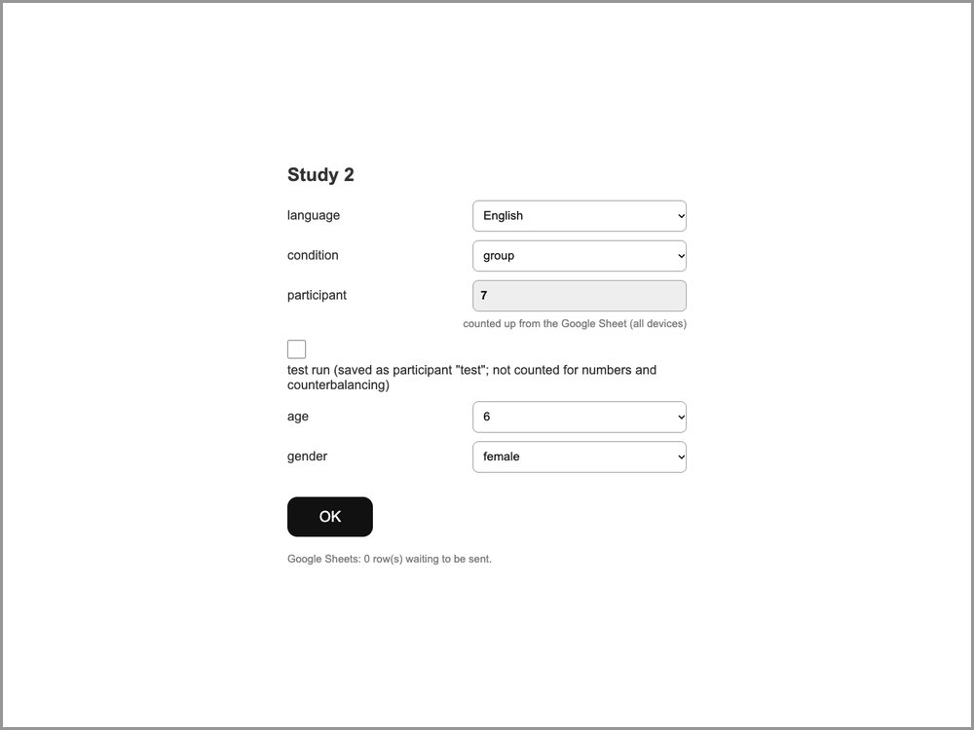 | What to do  Open the study link on the iPad. Choose the language and the child’s age and gender. Leave the condition on “balanced (automatic)” unless your supervisor tells you otherwise: the app then chooses the group or no-group condition. The participant number is filled in automatically. For a practice session, tick “test run”. Then tap OK.

Welcome and team choice
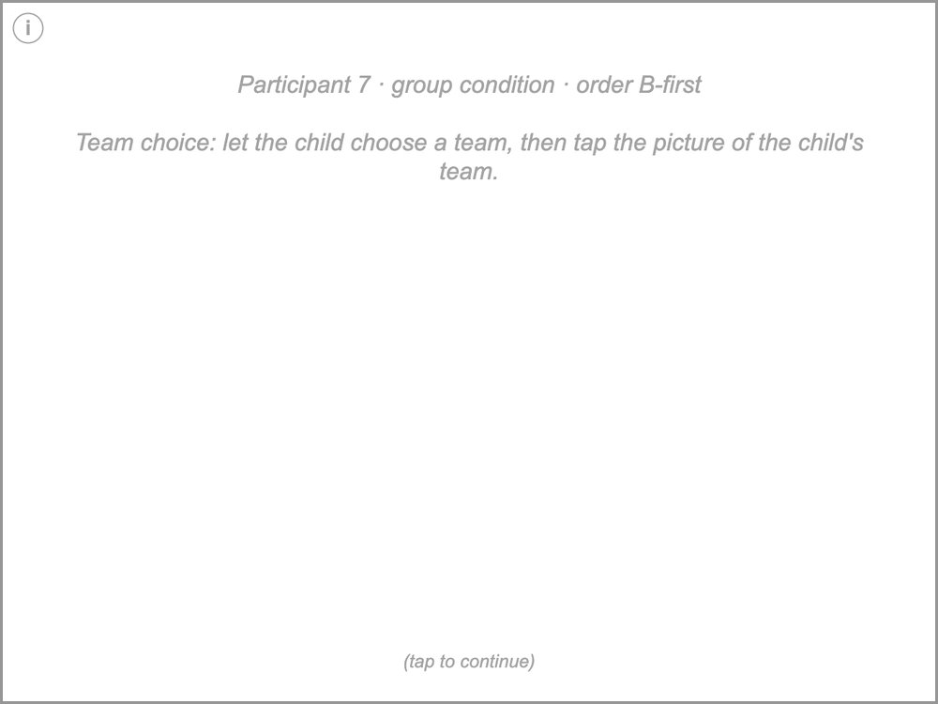 | What to do  Participant 7 · group condition · order B-first  Team choice: let the child choose a team, then tap the picture of the child's team.  What to say  "Hi, what's your name? It's very nice to meet you. My name is ... Do you want to play a game today?"  "The game we will play has two teams, the Moon team and the Sun team." [show the team pictures]  "What team do you want to be on today?"

The child chooses a team
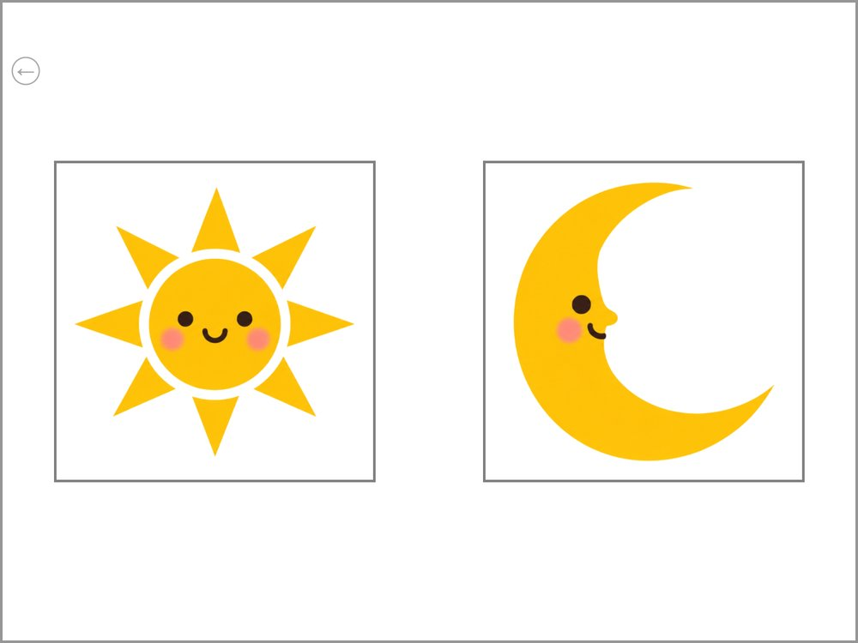 | What to do  The child chooses a team. Tap the picture of the team the child picks.

The two teams
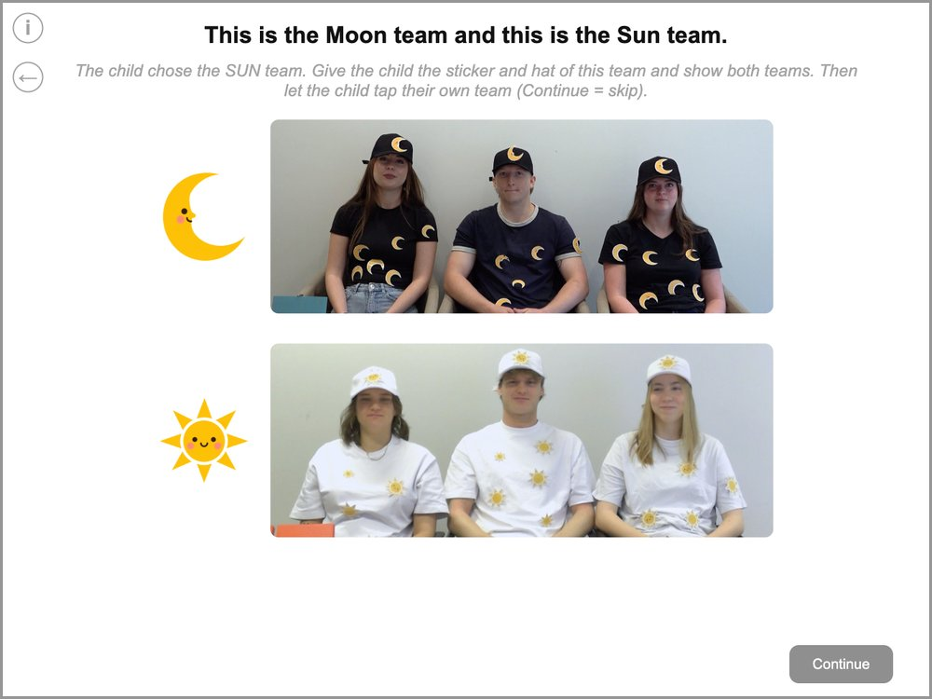 | What to do  The child chose the SUN team. Give the child the sticker and hat of this team and show both teams. Then let the child tap their own team (Continue = skip).  What to say  "Okay! So I have a couple of things for you. First, I have a special Sun team sticker for you." [give the sticker]  "I also have a special Sun team hat for you." [give the hat]  "Great, now you are part of the Sun team!"  [point to the Sun team] "Here are some people who are also on your team, the Sun team."  [point to the Moon team] "And here are some people who are on the other team, the Moon team."  "Can you show me your team? Tap on your team!"

Start in the no-group condition
In the no-group condition the child does not join a team, so the first screens are different. From the sticker task on, everything is the same as in the group condition.

Welcome (no-group condition)
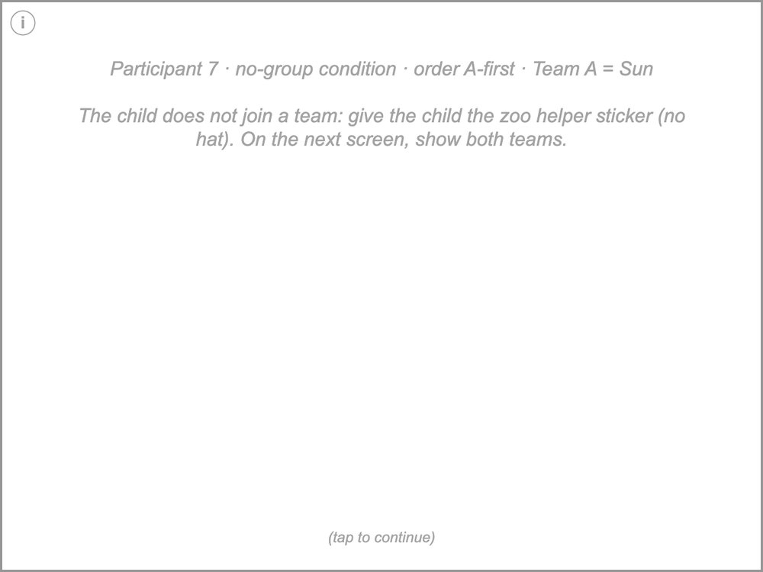 | What to do  Participant 7 · no-group condition · order A-first · Team A = Sun  The child does not join a team: give the child the zoo helper sticker (no hat). On the next screen, show both teams.  What to say  "Hi, what's your name? It's very nice to meet you. My name is ... Do you want to play a game today?"  "In this game there are two teams, the Moon team and the Sun team. Today you are not on a team. You will be our zoo helper!"  "I have something for you: a special zoo helper sticker." [give the sticker]

The two teams (no-group condition)
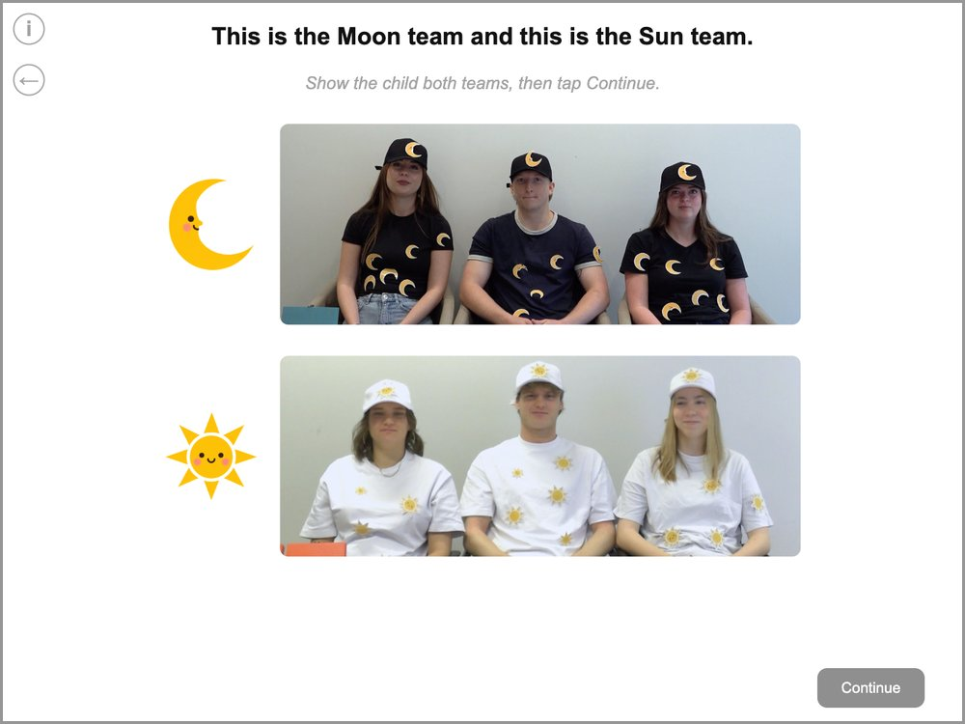 | What to do  Show the child both teams, then tap Continue.  In the no-group condition, the tablet says “the Moon team” and “the Sun team” in all later screens, instead of “your team” and “the other team”.  What to say  [point to the Moon team] "Here are some people who play on the Moon team."  [point to the Sun team] "And here are some people who play on the Sun team."

2. Stickers and play question

Sticker task: introduction
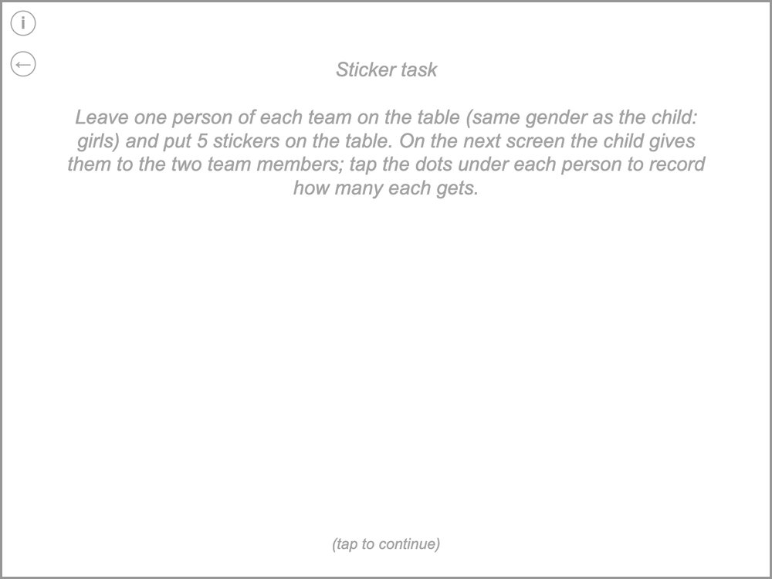 | What to do  Sticker task  Leave one person of each team on the table (same gender as the child: girls) and put 5 stickers on the table. On the next screen the child gives them to the two team members; tap the dots under each person to record how many each gets.  What to say  "Now I will ask you some questions about the two teams. Let's move these people out of the way." [leave one person of each team]  "Now I have some stickers here, let's see how many I have. I have 1, 2, 3, 4, 5 stickers. And now you can tell me how many stickers to give each of these two girls."  [next screen, point to each person]  "So out of these 5 stickers, how many stickers should I give to this girl from your team?"  "Okay, and how many stickers should I give to this girl from the other team?"  [move the stickers out of sight]

Sticker task
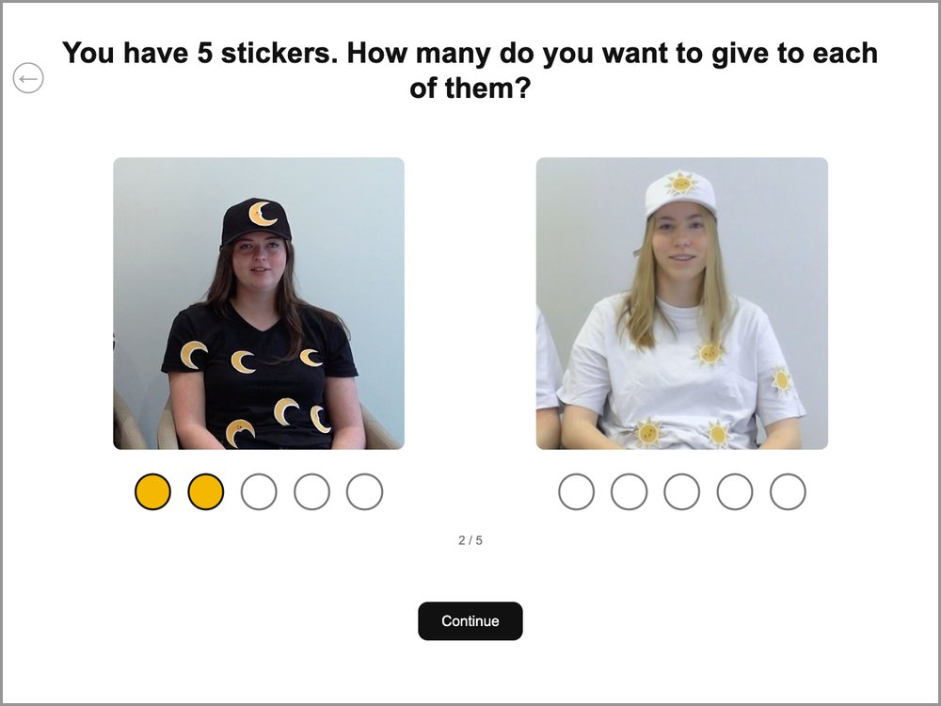 | What to do  The child gives the 5 stickers to the two people. Tap the dots under each person to record how many stickers that person gets. Then tap “Continue”.

Play question
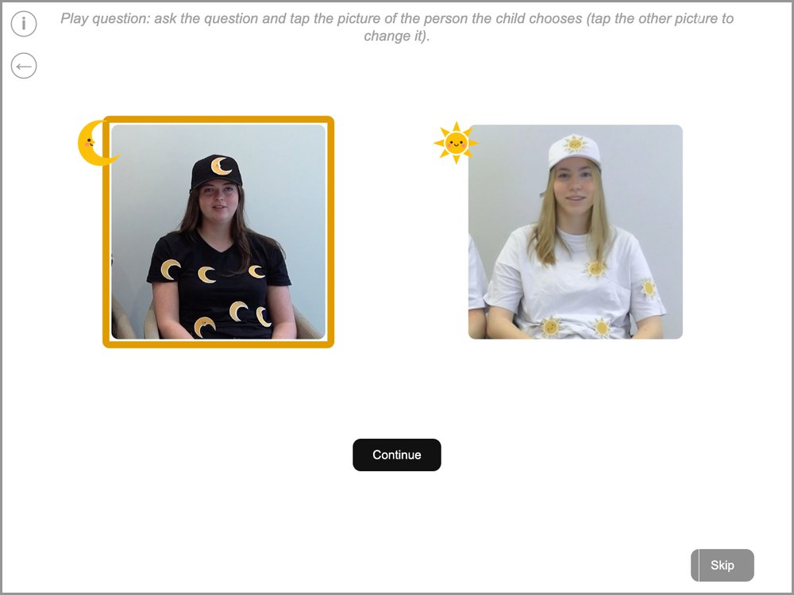 | What to do  Play question: ask the question and tap the picture of the person the child chooses (tap the other picture to change it).  Tap the picture of the person the child points to; a frame shows the choice. To change it, tap the other picture. Then “Continue”. If the child does not choose, tap “Skip”.  What to say  [point to this girl from the other team, then to this girl from your team] "Who would you rather play with: this girl from the other team or this girl from your team?" [let the child point]  [move the photos out of sight] "Later we'll hear from these two teams about the game we will play."

3. Round 1

Round 1: introducing the game
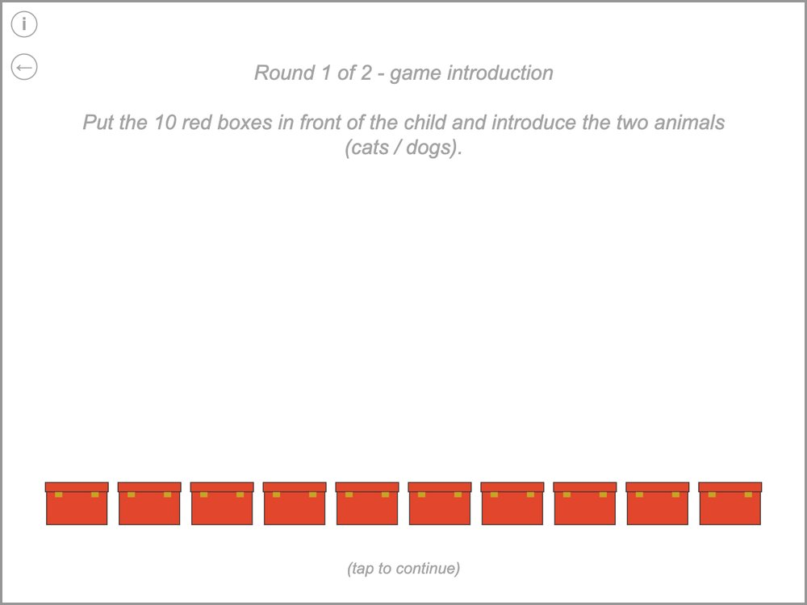 | What to do  Round 1 of 2 - game introduction  Put the 10 red boxes in front of the child and introduce the two animals (cats / dogs).  What to say  "Now we can play the game! The game today involves a zoo. See, here is the zoo! Many animals are part of the zoo, including some cats [hold up the cat] and dogs [hold up the dog]." [let the child name both animals]  "Your job will be to figure out whether there are more cats or more dogs in the boxes. Right now, each one of these boxes has an animal in it, either a cat or a dog. I don't know whether there are more cats or more dogs in the boxes."

Scale practice: show how it works
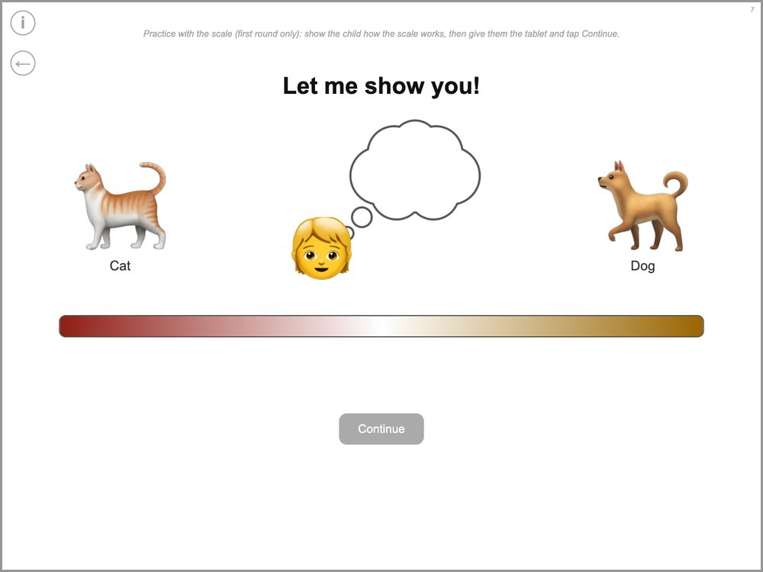 | What to do  Practice with the scale (first round only): show the child how the scale works, then give them the tablet and tap Continue.  What to say  "Later, I will ask you what you think about the boxes, and we'll use this picture for you to tell me." [move the marker yourself]  "If you really think there are more cats, you can place your marker here [far cat side]. If you kind of think there are more cats, somewhere in here [middle of the cat side]." [the same for the dogs]  "And if you don't know, you can place your marker here." [the middle, where the ? appears]

Scale practice 1 of 5
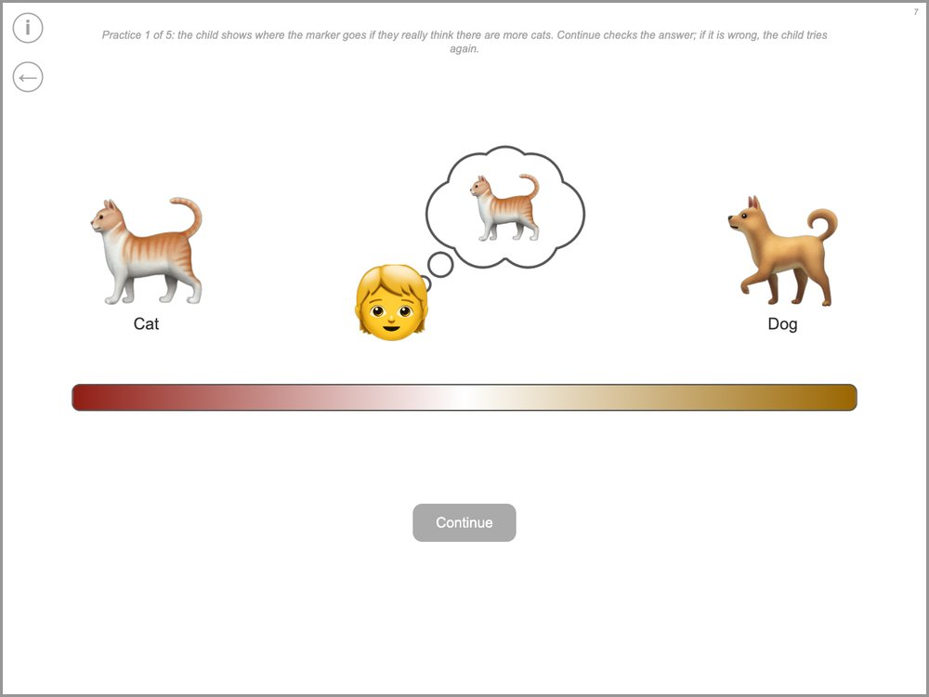 | What to do  Practice 1 of 5: the child shows where the marker goes if they really think there are more cats. Continue checks the answer; if it is wrong, the child tries again.  What to say  "Okay, so later when I ask you, if you really thought there were more cats, where would you place your marker?"

Scale practice 2 of 5
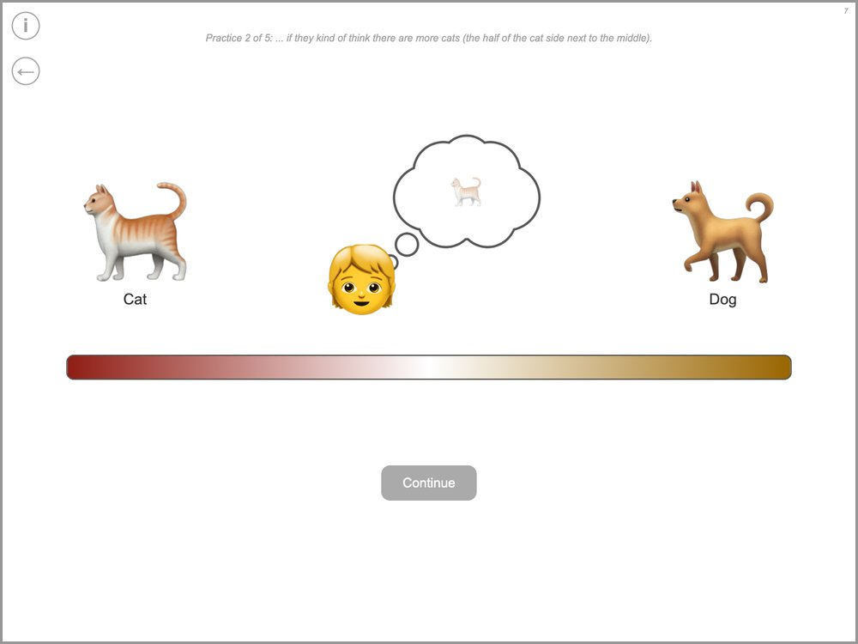 | What to do  Practice 2 of 5: ... if they kind of think there are more cats (the half of the cat side next to the middle).  What to say  "Good, and if you kind of thought there were more cats, where would you place your marker?"

Scale practice 3 of 5
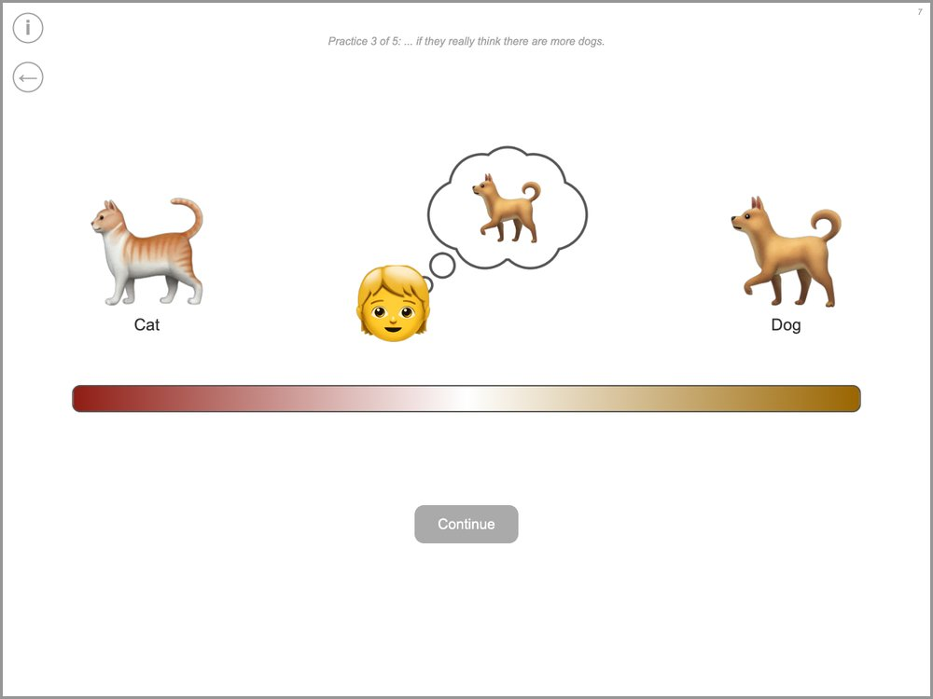 | What to do  Practice 3 of 5: ... if they really think there are more dogs.  What to say  "Good, and if you really thought there were more dogs, where would you place your marker?"

Scale practice 4 of 5
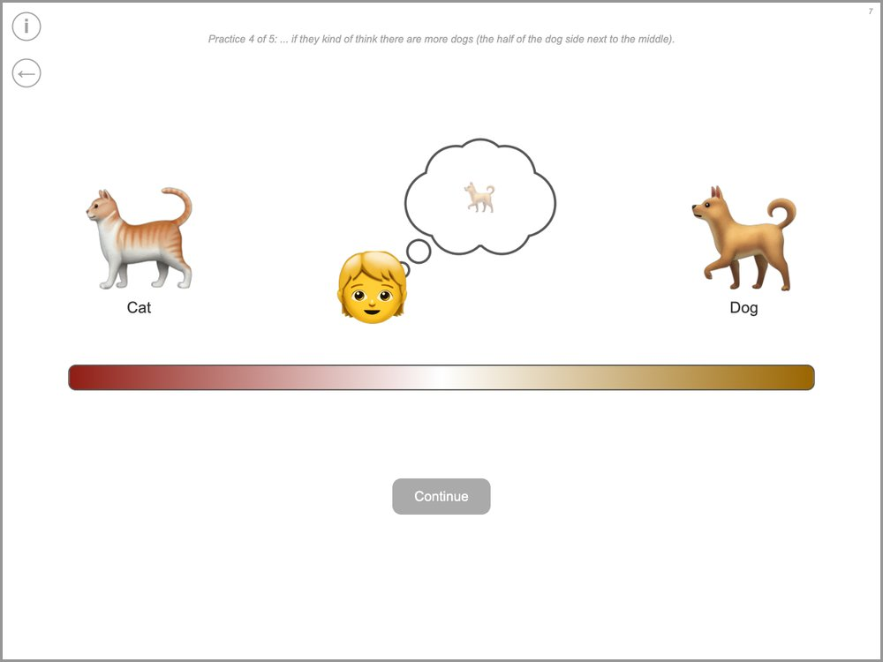 | What to do  Practice 4 of 5: ... if they kind of think there are more dogs (the half of the dog side next to the middle).  What to say  "Good, and if you kind of thought there were more dogs, where would you place your marker?"

Scale practice 5 of 5
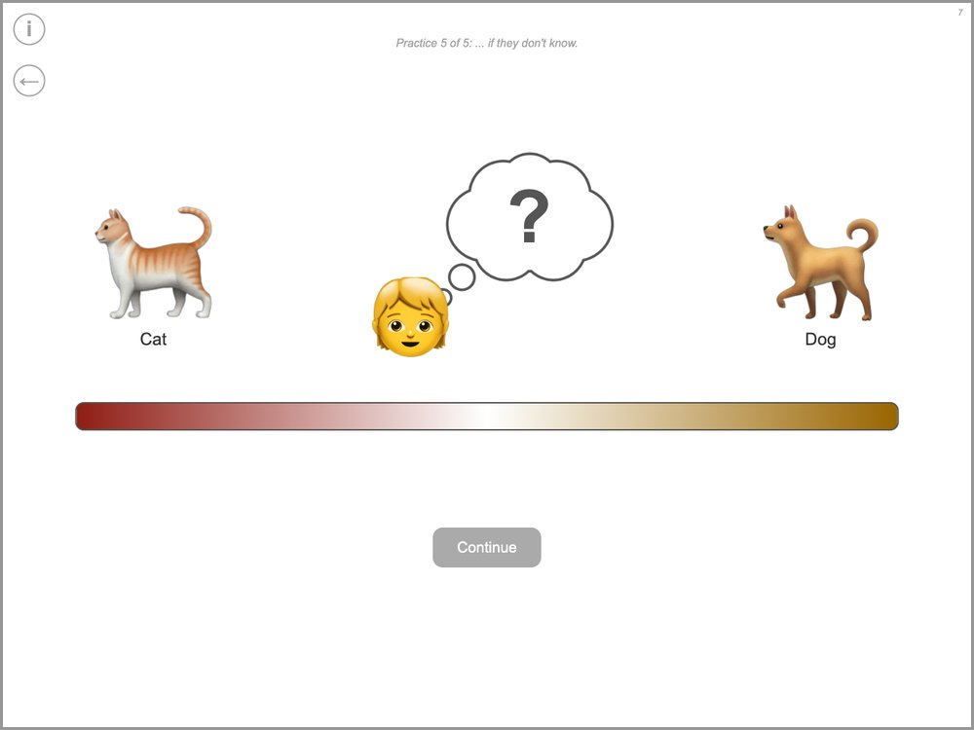 | What to do  Practice 5 of 5: ... if they don't know.  What to say  "Good, and if you didn't know, where would you place your marker?"

Step 2: what do the teams think? – first video
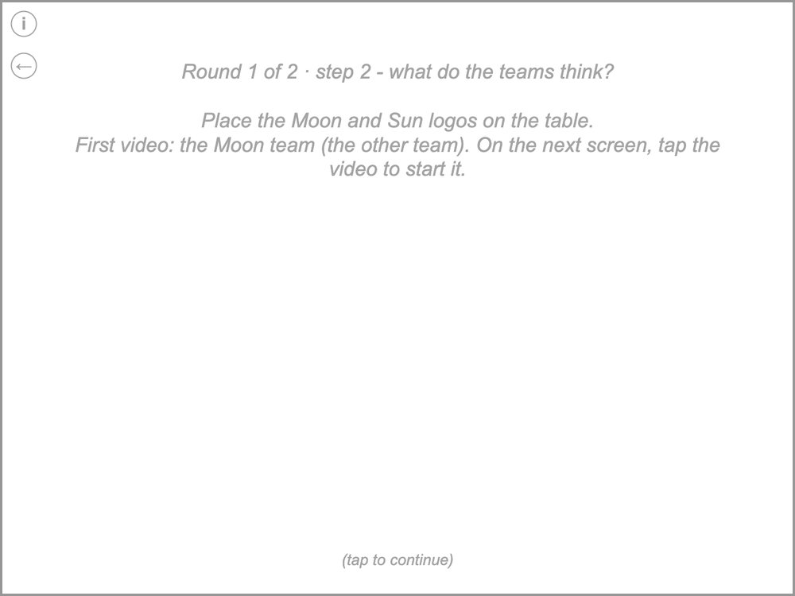 | What to do  Round 1 of 2 · step 2 - what do the teams think?  Place the Moon and Sun logos on the table.  First video: the Moon team (the other team). On the next screen, tap the video to start it.  What to say  "Okay great, I will bring the tablet back out later." [move the tablet out of sight]  "Earlier, the Moon team and the Sun team played this game with these boxes, and each team looked at the boxes. Now we are going to watch videos from the two teams and see what they think: whether they think there are more cats or more dogs."  "Remember, you are part of the Sun team."  [place the logos] "Look, it's the other team! And those are the same boxes we have right here." [point to the boxes]  "Let's see what the other team thinks."

Video
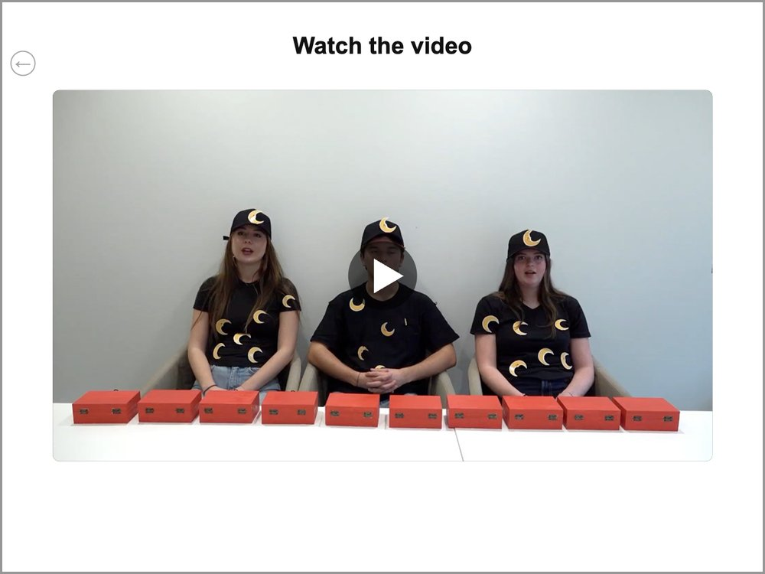 | What to do  Tap the video to start it. When it has finished, tap “Continue”. (“Replay” plays it again.)

Between the two videos
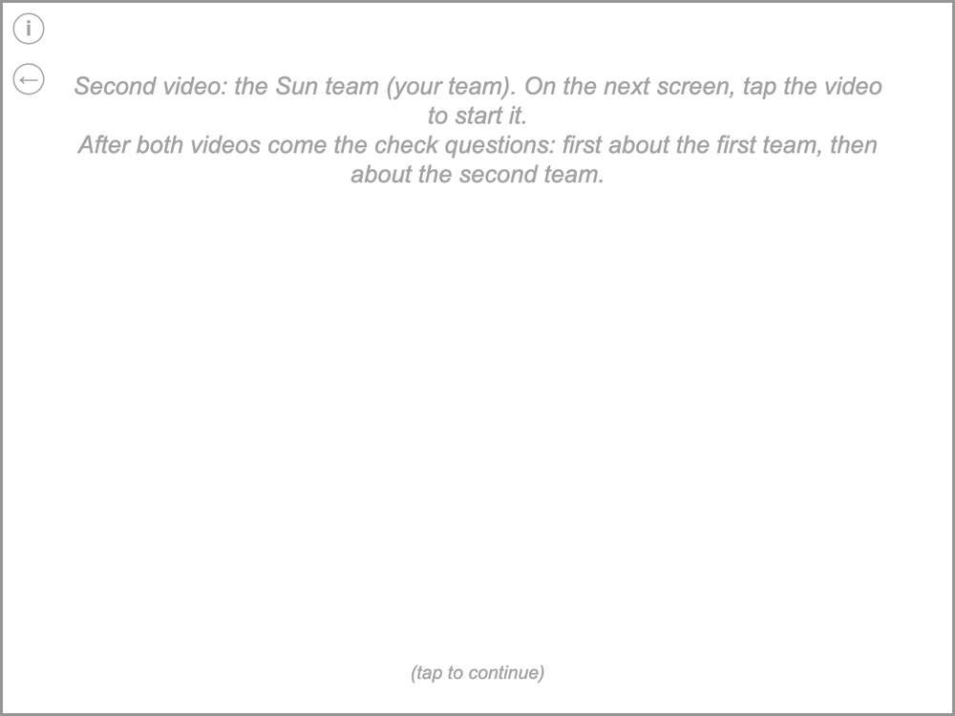 | What to do  Second video: the Sun team (your team). On the next screen, tap the video to start it.  After both videos come the check questions: first about the first team, then about the second team.  After this screen comes the second video (tap the video to start it, then “Continue”). After the second video come the check questions.  What to say  "Now let's see what your team thinks."

Check question: first team
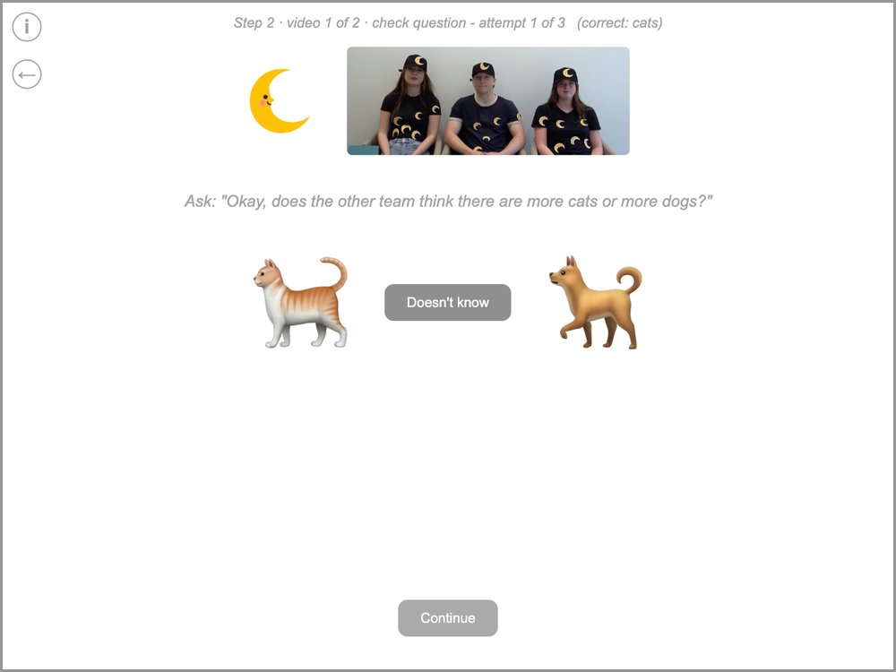 | What to do  Step 2 · video 1 of 2 · check question - attempt 1 of 3 (correct: cats)  Ask: "Okay, does the other team think there are more cats or more dogs?"  Tap the child’s answer (“Doesn't know” if the child doesn’t know), then “Continue”. The logo and photo at the top show which team the question is about; the grey line at the top shows the correct answer.  What to say  If right: "That's right, the other team thinks there are more cats."

Only if an answer was wrong
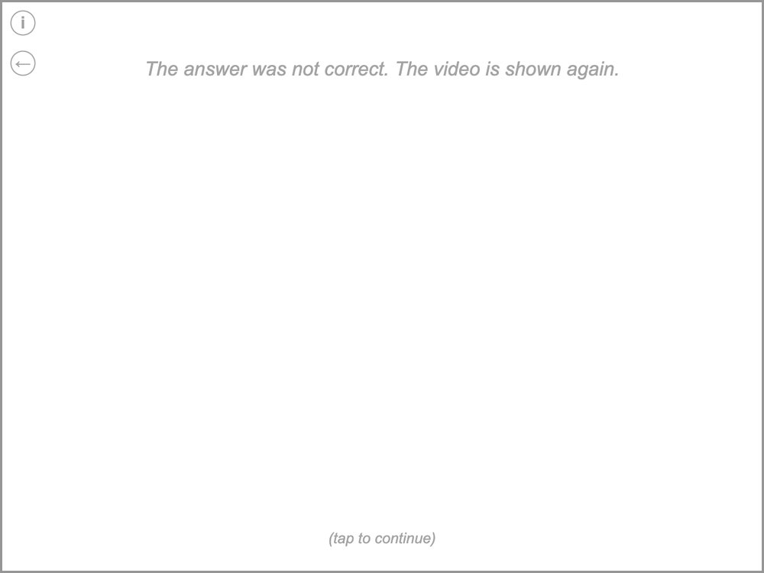 | What to do  The answer was not correct. The video is shown again.  This screen only appears if an answer was wrong. Then that team’s video is shown again and its question is asked again (at most 3 tries).  What to say  "Hm, let's watch the video one more time!"

Check question: second team
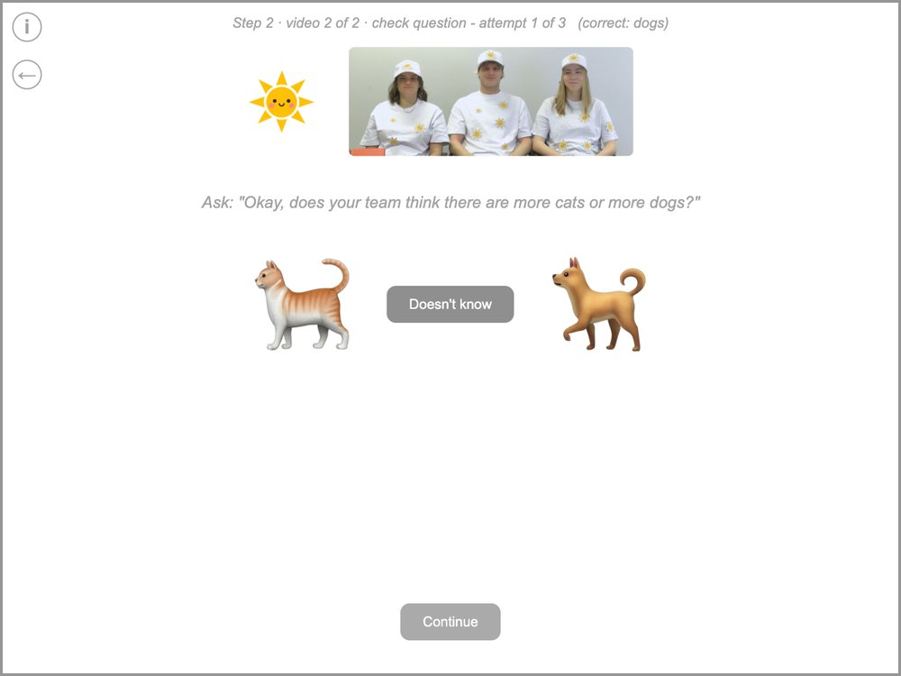 | What to do  Step 2 · video 2 of 2 · check question - attempt 1 of 3 (correct: dogs)  Ask: "Okay, does your team think there are more cats or more dogs?"  The same question about the second team (see the logo and photo at the top).  What to say  If right: "That's right, your team thinks there are more dogs."

Summary of step 2
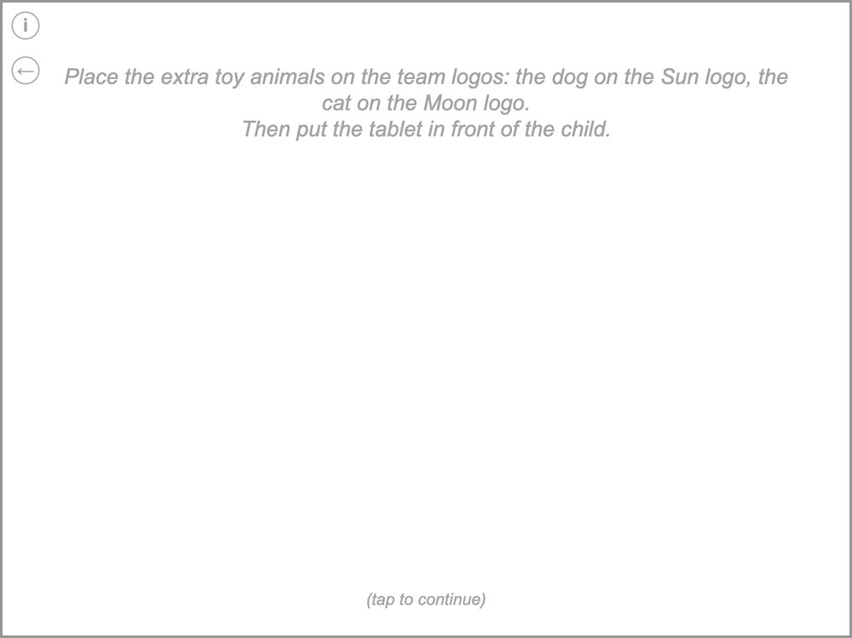 | What to do  Place the extra toy animals on the team logos: the dog on the Sun logo, the cat on the Moon logo.  Then put the tablet in front of the child.  What to say  "So your team thinks there are more dogs, and the other team thinks there are more cats."

Step 3: first answer – which animal?
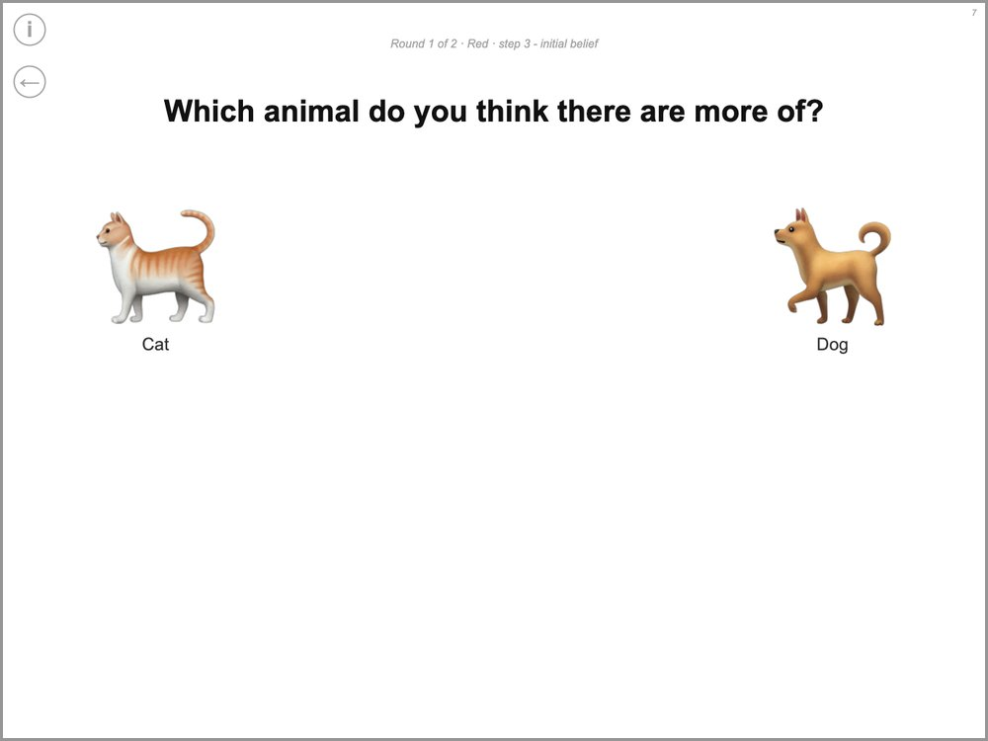 | What to do  Round 1 of 2 · Red · step 3 - initial belief  The child taps the animal they think there are more of. Then the scale appears (next picture).  What to say  "Okay, so what do you think? Do you think there are more cats or more dogs in the boxes?"

Step 3: first answer – how sure?
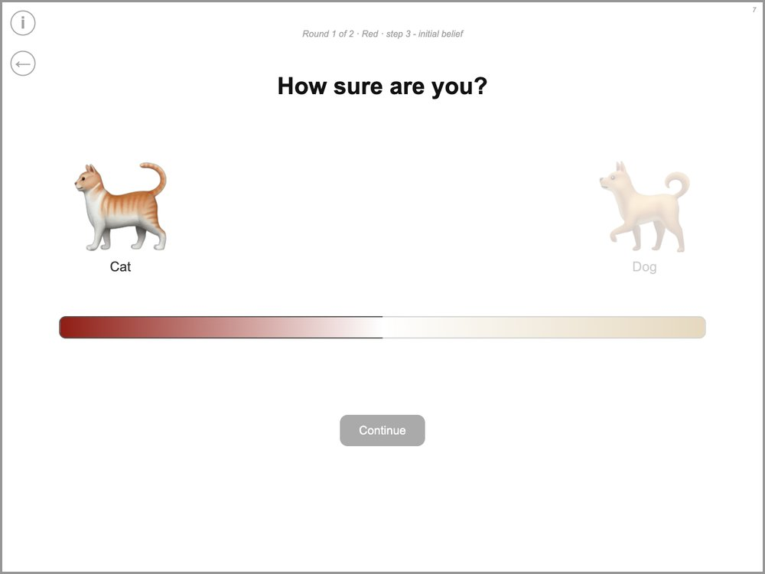 | What to do  Round 1 of 2 · Red · step 3 - initial belief  The child places the marker on the scale. Then tap “Continue”.  What to say  "Okay. And now you can tell me how sure you are that there are more cats. Do you really think there are more cats, do you kind of think there are more cats, or do you not really know whether there are more cats?" [point to each part of the scale]  If the child doesn't move the marker: "So where do you want to place your marker?"

Step 4: why do the teams think that?
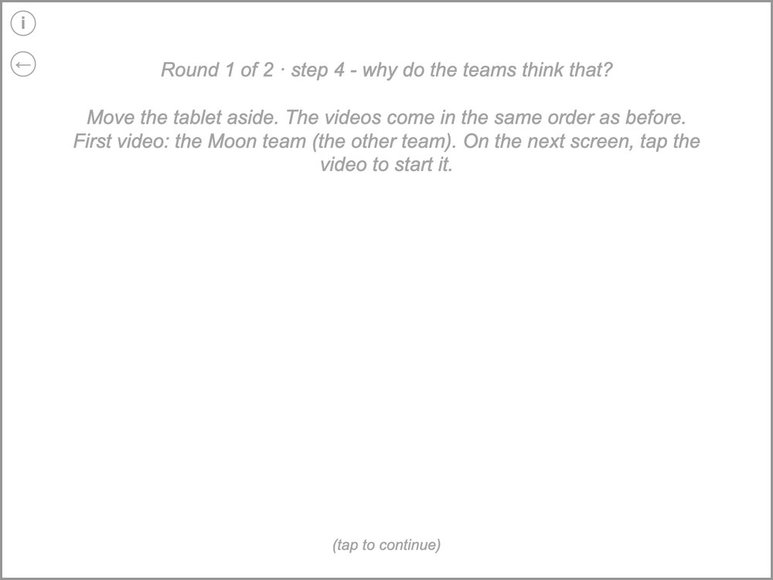 | What to do  Round 1 of 2 · step 4 - why do the teams think that?  Move the tablet aside. The videos come in the same order as before.  First video: the Moon team (the other team). On the next screen, tap the video to start it.  Then, as in step 2: the first video, the screen between the two videos, the second video, and then the check questions.  What to say  "The teams also told us why they think that. Let's watch them again!"

Check questions with reason: first team
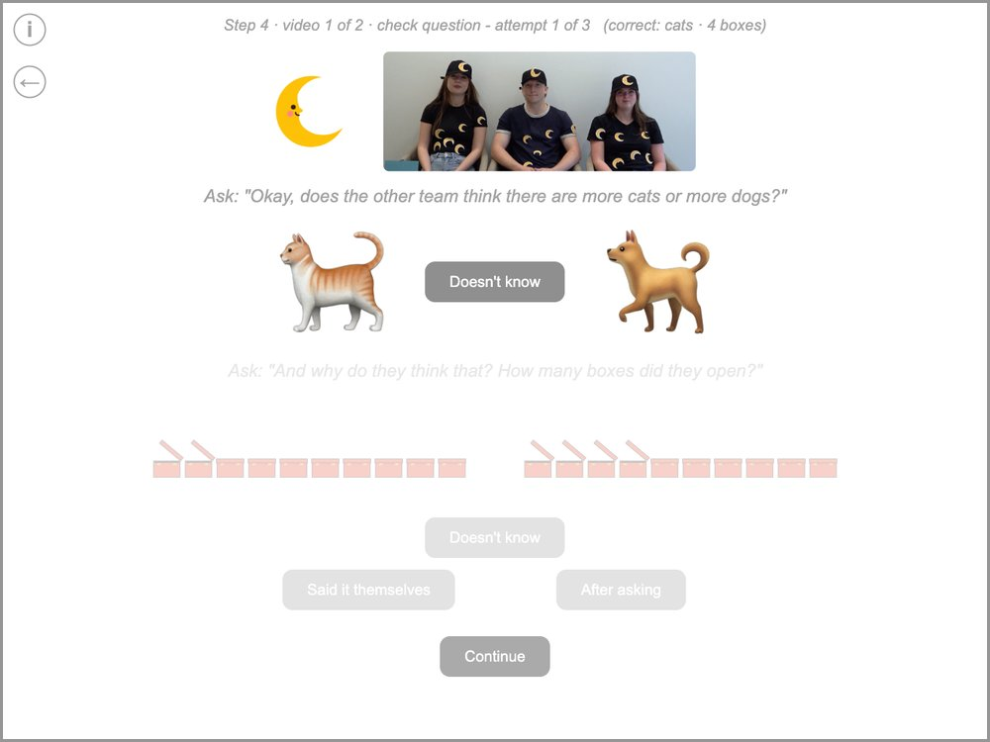 | What to do  Step 4 · video 1 of 2 · check question - attempt 1 of 3 (correct: cats · 4 boxes)  Ask: "Okay, does the other team think there are more cats or more dogs?"  Ask: "And why do they think that? How many boxes did they open?"  Tap the child’s answers: first the animal, then the boxes (“Doesn't know” if the child doesn’t know). Then tap “Said it themselves” if the child gave the reason on their own, or “After asking” if the child only gave it after you asked further. Then tap “Continue”. The grey line at the top shows the correct answers.  What to say  If right: "That's right, the other team thinks there are more cats, because they opened four boxes and they were all cats."

Check questions with reason: second team
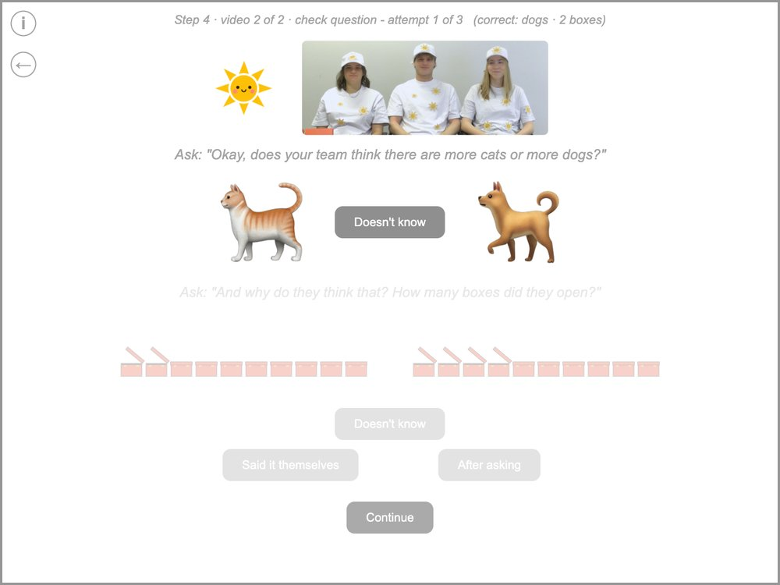 | What to do  Step 4 · video 2 of 2 · check question - attempt 1 of 3 (correct: dogs · 2 boxes)  Ask: "Okay, does your team think there are more cats or more dogs?"  Ask: "And why do they think that? How many boxes did they open?"  The same as for the first team, now about the second team (see the logo and photo at the top).  What to say  If right: "That's right, your team thinks there are more dogs, because they opened two boxes and they were all dogs."

Summary of step 4
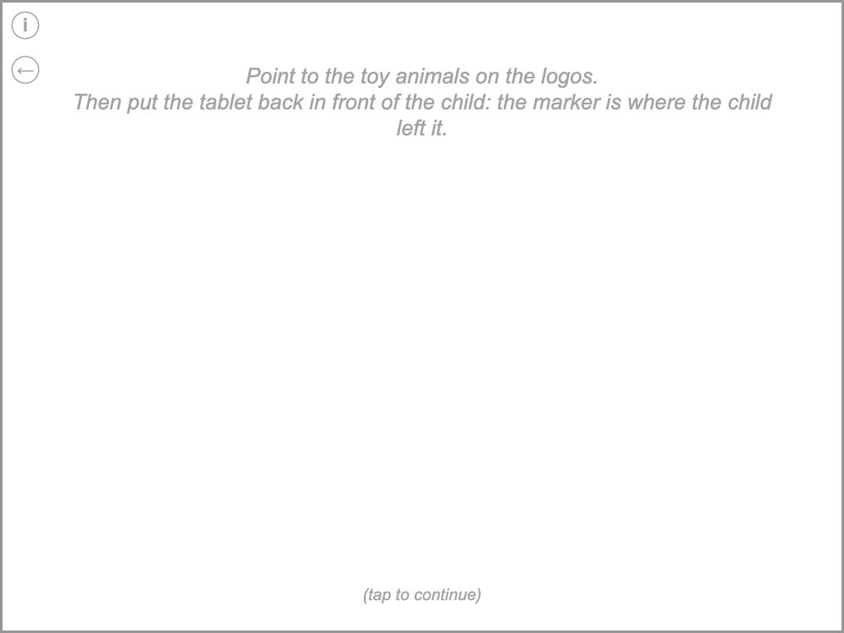 | What to do  Point to the toy animals on the logos.  Then put the tablet back in front of the child: the marker is where the child left it.  What to say  "So your team thinks there are more dogs, because they opened two boxes, and the other team thinks there are more cats, because they opened four boxes."

Step 5: final answer
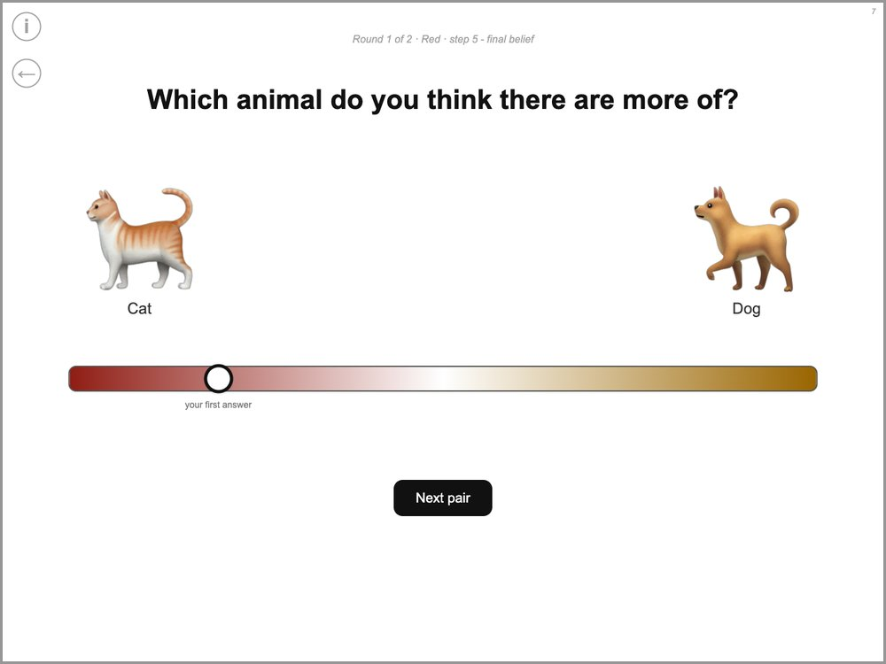 | What to do  Round 1 of 2 · Red · step 5 - final belief  The marker starts at the child’s first answer. The child can move it or leave it there. Then tap “Next pair” (“Finish” in round 2).  What to say  "Earlier you said that you really thought there are more cats in the boxes. So now what do you think? Do you want to move your marker or leave it where it is?"

4. Round 2

Round 2
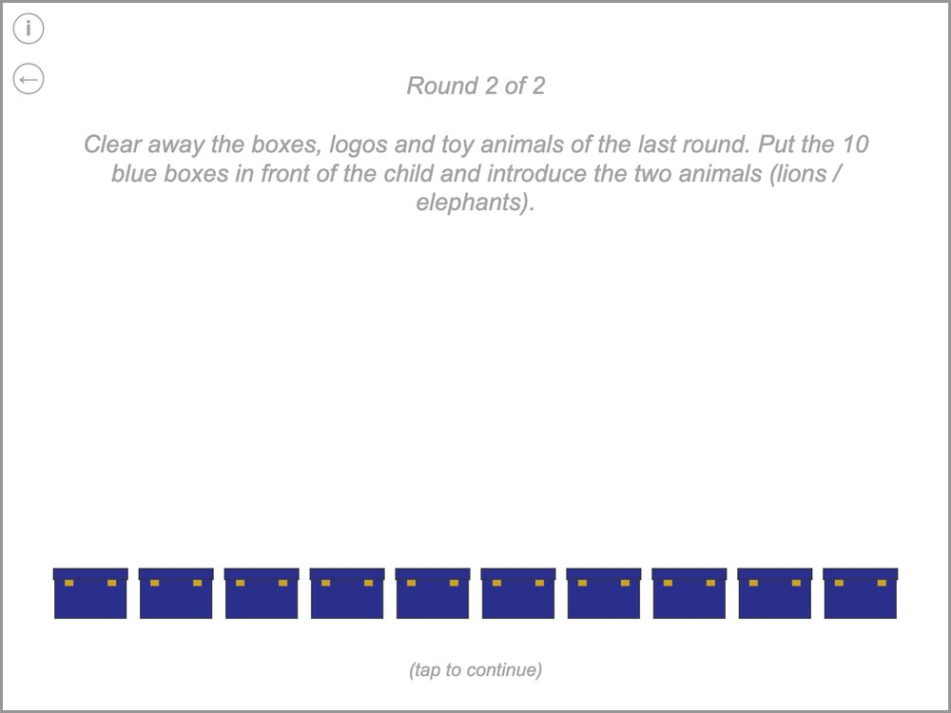 | What to do  Round 2 of 2  Clear away the boxes, logos and toy animals of the last round. Put the 10 blue boxes in front of the child and introduce the two animals (lions / elephants).  Round 2 starts with this screen (new boxes and animals; the tablet says which colour). After it come the same screens as in round 1, from step 2 on – without the scale practice. Round 2 is the last round.  What to say  "Great job! Now we will play again, with new boxes and new animals. These boxes have lions [hold up the lion] and elephants [hold up the elephant] in them." [let the child name both animals]  "Each box has either a lion or an elephant in it. Your job is to figure out whether there are more lions or more elephants. I don't know whether there are more lions or more elephants in the boxes."

5. End

Solution
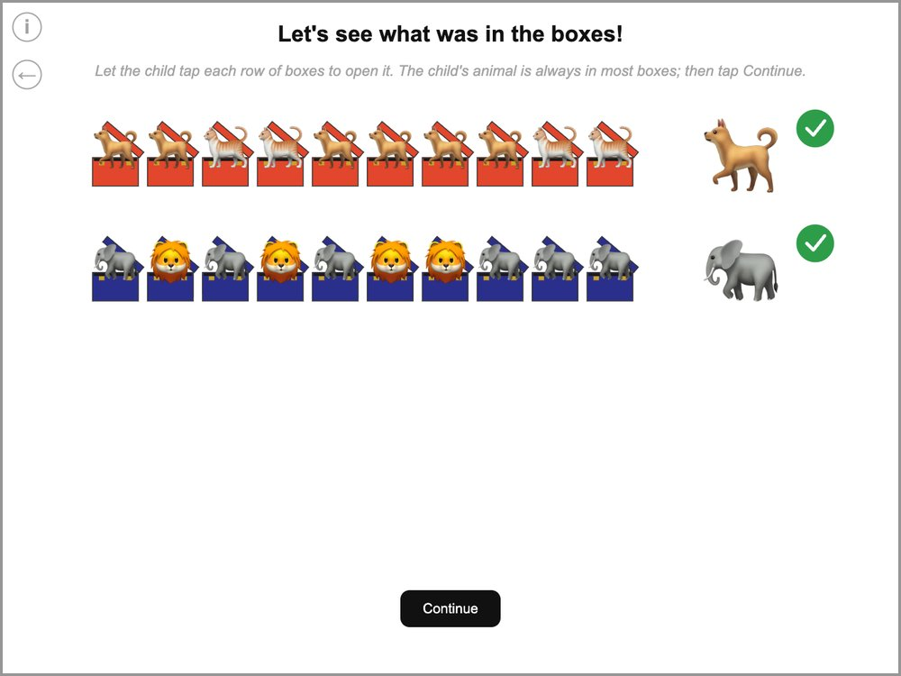 | What to do  Let the child tap each row of boxes to open it. The child's animal is always in most boxes; then tap Continue.  A tick appears next to each row the child has opened.  What to say  "Let's see what was in the boxes! Tap on the boxes." [after each row] "Look, there were more of your animal. You were right!"

End
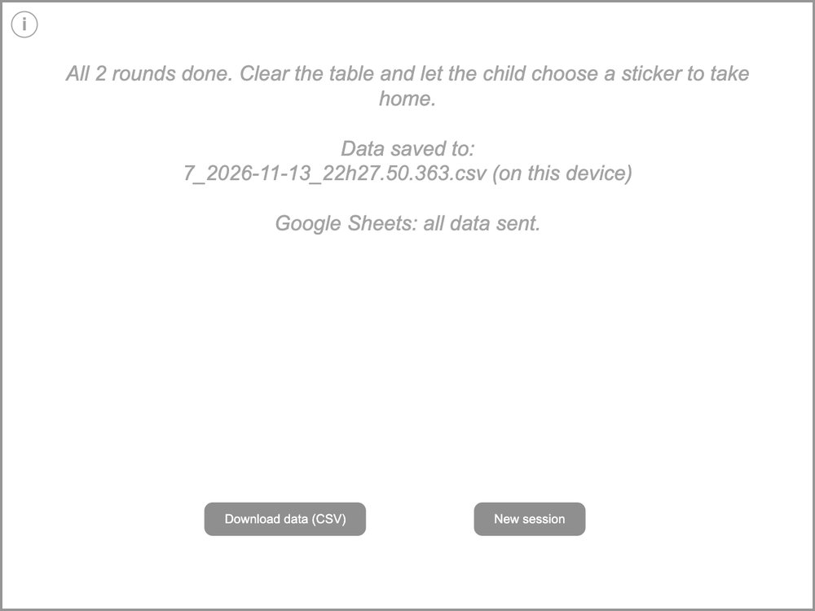 | What to do  All 2 rounds done. Clear the table and let the child choose a sticker to take home.  Data saved to:  7_2026-11-13_22h27.50.363.csv (on this device)  Google Sheets: all data sent.  Check the line about Google Sheets: it should say that all data were sent. If it does not, tap “Download data (CSV)” as a backup and tell your supervisor. “New session” starts the next child.  What to say  "Awesome! Now we are all done with our game today. You did such a great job! For all of your hard work, you can choose any sticker in here you want to take home!" [show the sticker box]

